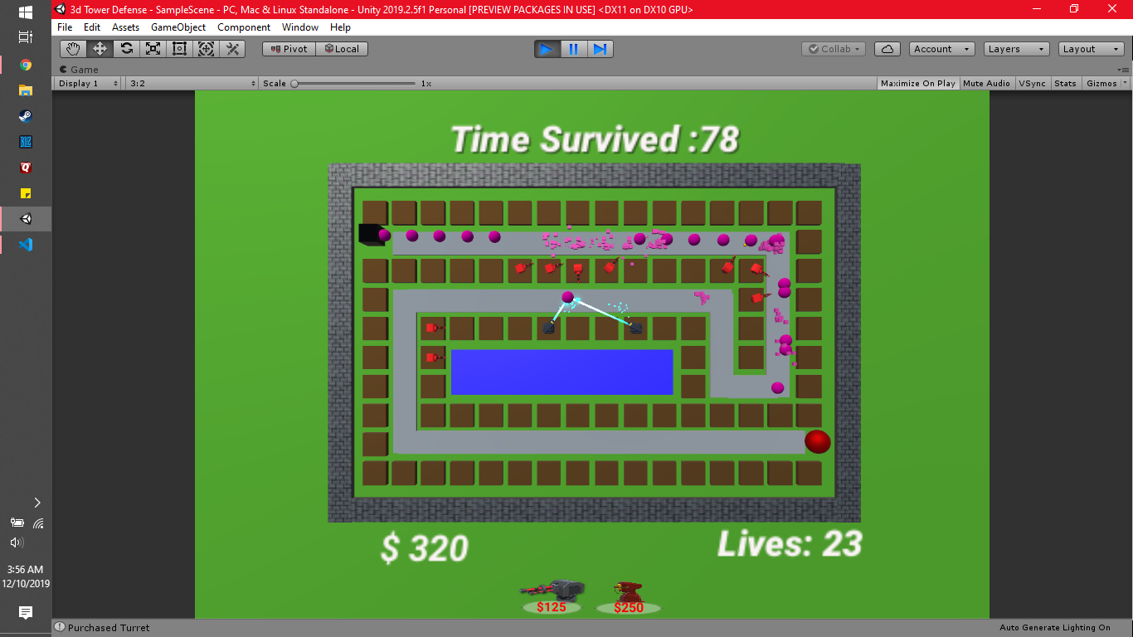

**Game By: Nick De Santi & Quinn Irons**

**3D Tower Defense**